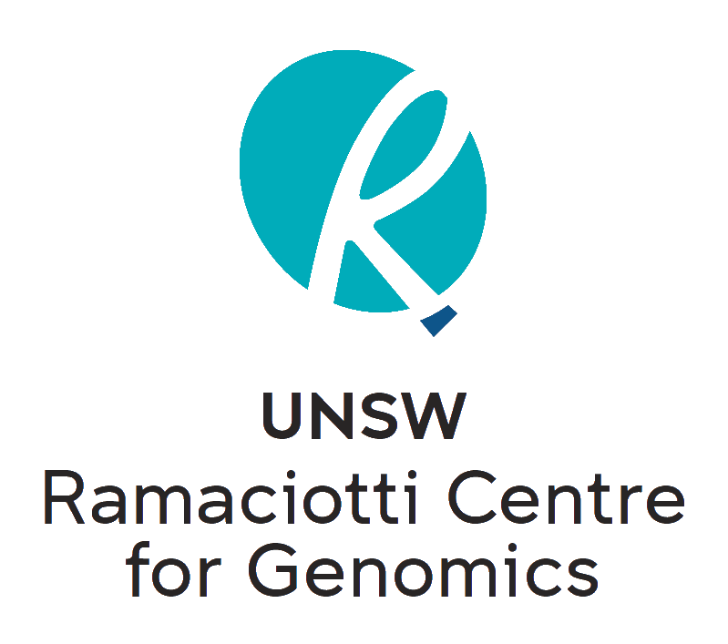
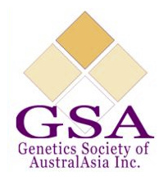

Genetics Society of Australasia 2021 Student Research Grant Scheme

The GSA are pleased to announce our 2021 Student Research Grant Scheme including an Illumina NovaSeq Mini Grant in conjunction with the Ramaciotti Centre for Genomics. Researchers with innovative projects are invited to submit a 700-word application outlining how next generation sequencing can be utilised to advance their research. The winner will receive an Illumina NovaSeq 6000 S1 300cycle flowcell (up to 1.6B reads/480Gb data) and library construction (choose either WGS prep of up to 24 samples OR Total RNA-seq of up to 16 samples OR mRNA-seq of up to 24 samples). Submit your entry by completing the attached application form and emailing it to GSA@asnevents.net.au with the subject heading “Illumina NovaSeq Mini Grant”. Terms and conditions apply.

About the Ramaciotti Centre for Genomics
The Ramaciotti Centre for Genomics, located at UNSW, is a not-for-profit provider of genomic services. We enable access to state-of-the-art, cutting edge technologies at affordable prices and deliver data of the highest quality. Our technology suite includes long- and short-read next-generation sequencing, genotyping microarrays, high-throughput qPCR and capillary sequencing. Our professional team of scientists have many years of experience providing researchers with a personalised service from design through to downstream analysis.

Terms & Conditions
• Applicants must complete the application form in full.
• The successful recipient will receive sequencing data from an Illumina NovaSeq 6000 S1 300cycle flowcell, (up to 1.6B reads/480Gb data).
• The successful recipient can utilise Ramaciotti Centre’s library prep service free of charge. Library prep kit options available: Illumina DNA PCR-free prep, Illumina Stranded Total RNA Ribo-Zero Plus and Illumina Stranded mRNA. Purified DNA or RNA must be submitted, as applicable per prep option.
• The sequencing kit can also be used for a submission of a user-prepared library pool.
• Applications close on 1st of December 2021 at 5pm AEST. Late submissions will not be considered.
• DNA/RNA samples or libraries must be submitted and pass quality check before 1st of March 2022.
• All samples or libraries submitted for the sequencing run must be submitted in a single batch and conform with Ramaciotti Centre for Genomics submission guidelines.
• If needed please contact the Centre for technical advice, stating “GSA NovaSeq Mini Grant Enquiry” in the email heading (address: ramaciotti@unsw.edu.au)
• This grant is only open to postgraduate students enrolled in Australasian institutions and that hold current GSA memberships.
• The grant is for research only and cannot be used for commercial or clinical purposes.
• Applications will be reviewed by a panel of GSA, Ramaciotti Centre and Illumina representatives.
• The winner will be announced on social media including the GSA website, Facebook and Twitter and will be encouraged to present their research at the annual GSA conference.
• The successful applicant agrees to have their name and the purpose of the grant made public.
• Applicants agree to being contacted by Illumina for marketing purposes.

Name

Institution

Address

Email

Phone

Postgraduate Project Summary (250 word limit):

How will this grant be used? (250 word limit, please outline sample numbers and technical plan):

Why is your research important to the genetics community? (200 word limit)

