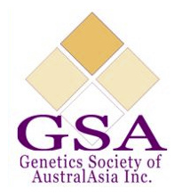

Genetics Society of Australasia 2020 Student Research Grant Scheme
(POCD Student Grant)

The GSA are pleased to announce our 2020 Student Research Grant Scheme including a set of CAPP Bravo pipettes (P10, P100, P1000) from Point of Care Diagnostics. Postgraduate researchers are invited to submit an application outlining their PhD project, how this award will be used to advance their research and why their research is important. Submit your entry by completing the attached application form and emailing it to GSAA.awards@gmail.com with the subject heading “POCD Student Grant”. Terms and conditions apply.

Terms & Conditions
• Applicants must complete the application form in full.
• The successful recipient will receive a set of CAPP Bravo pipettes (P10, P100, P1000) from Point of Care Diagnostics.
• Applications close on 1st November 2020 at 5pm AEST. Late submissions will not be considered.
• This grant is only open to postgraduate students enrolled in Australasian institutions and that hold current GSA memberships.
• Applications will be reviewed by a panel of GSA and POCD representatives.
• The winner will be announced on social media including our website, Facebook and Twitter. The successful applicant agrees to have their name and the purpose of the grant made public.
• The winner will be encouraged to present their research at the annual GSA conference.

Name
Institution
Address
Email
Phone

PhD Project Summary (250 word limit):

How will this grant improve your project? (250 word limit):

Why is your research important to the genetics community? (200 word limit)

